**PROJECT REPORT TEMPLEATE**

**JOB APPLICATION TRACKING SYSTEM**

**TEAM ID : NM2023TMID20833**

**1.INRODUCTION**

**1.1 Overview :**

Administrator should be able to create all base data including semester, Semester, candidate, is one of the lecture, should be the only one with ability to update internal its , Re-evaluation can be initialised by candidate for all internal results . Now dean can update the marks after re- evaluation .

**1.2 Purpose :**

* Marketing campaign management
* Resolving conflicts
* Performance Appraisal
* Training & Development
* Maintaining Healthy Work culture
* Organizing various activities
* Payroll Management .

**2. Problem Definition & Design Thinking**

**2.1 Empathy map** :

 An empathy map is a collaborative visualization used to articulate what we know about a particular type of user. It externalizes knowledge about users in order to

1) create a shared understanding of user needs, and

2) aid in decision making

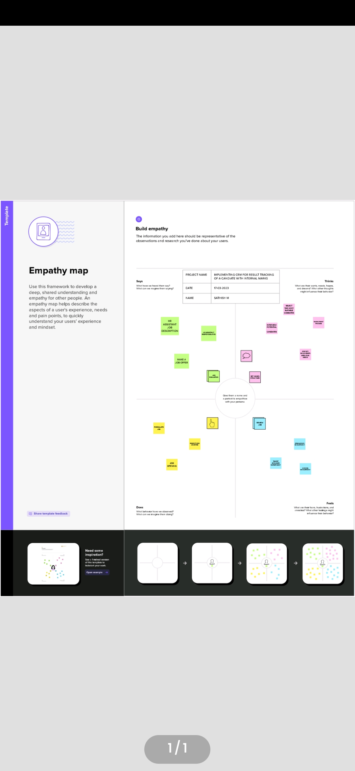

**2.2 Brainstorming :**

Brainstorming is a group problem-solving method that involves the spontaneous contribution of creative ideas and solutions. This technique requires intensive, freewheeling discussion in which every member of the group is encouraged to think aloud and suggest as many ideas as possible based on their diverse knowledge.

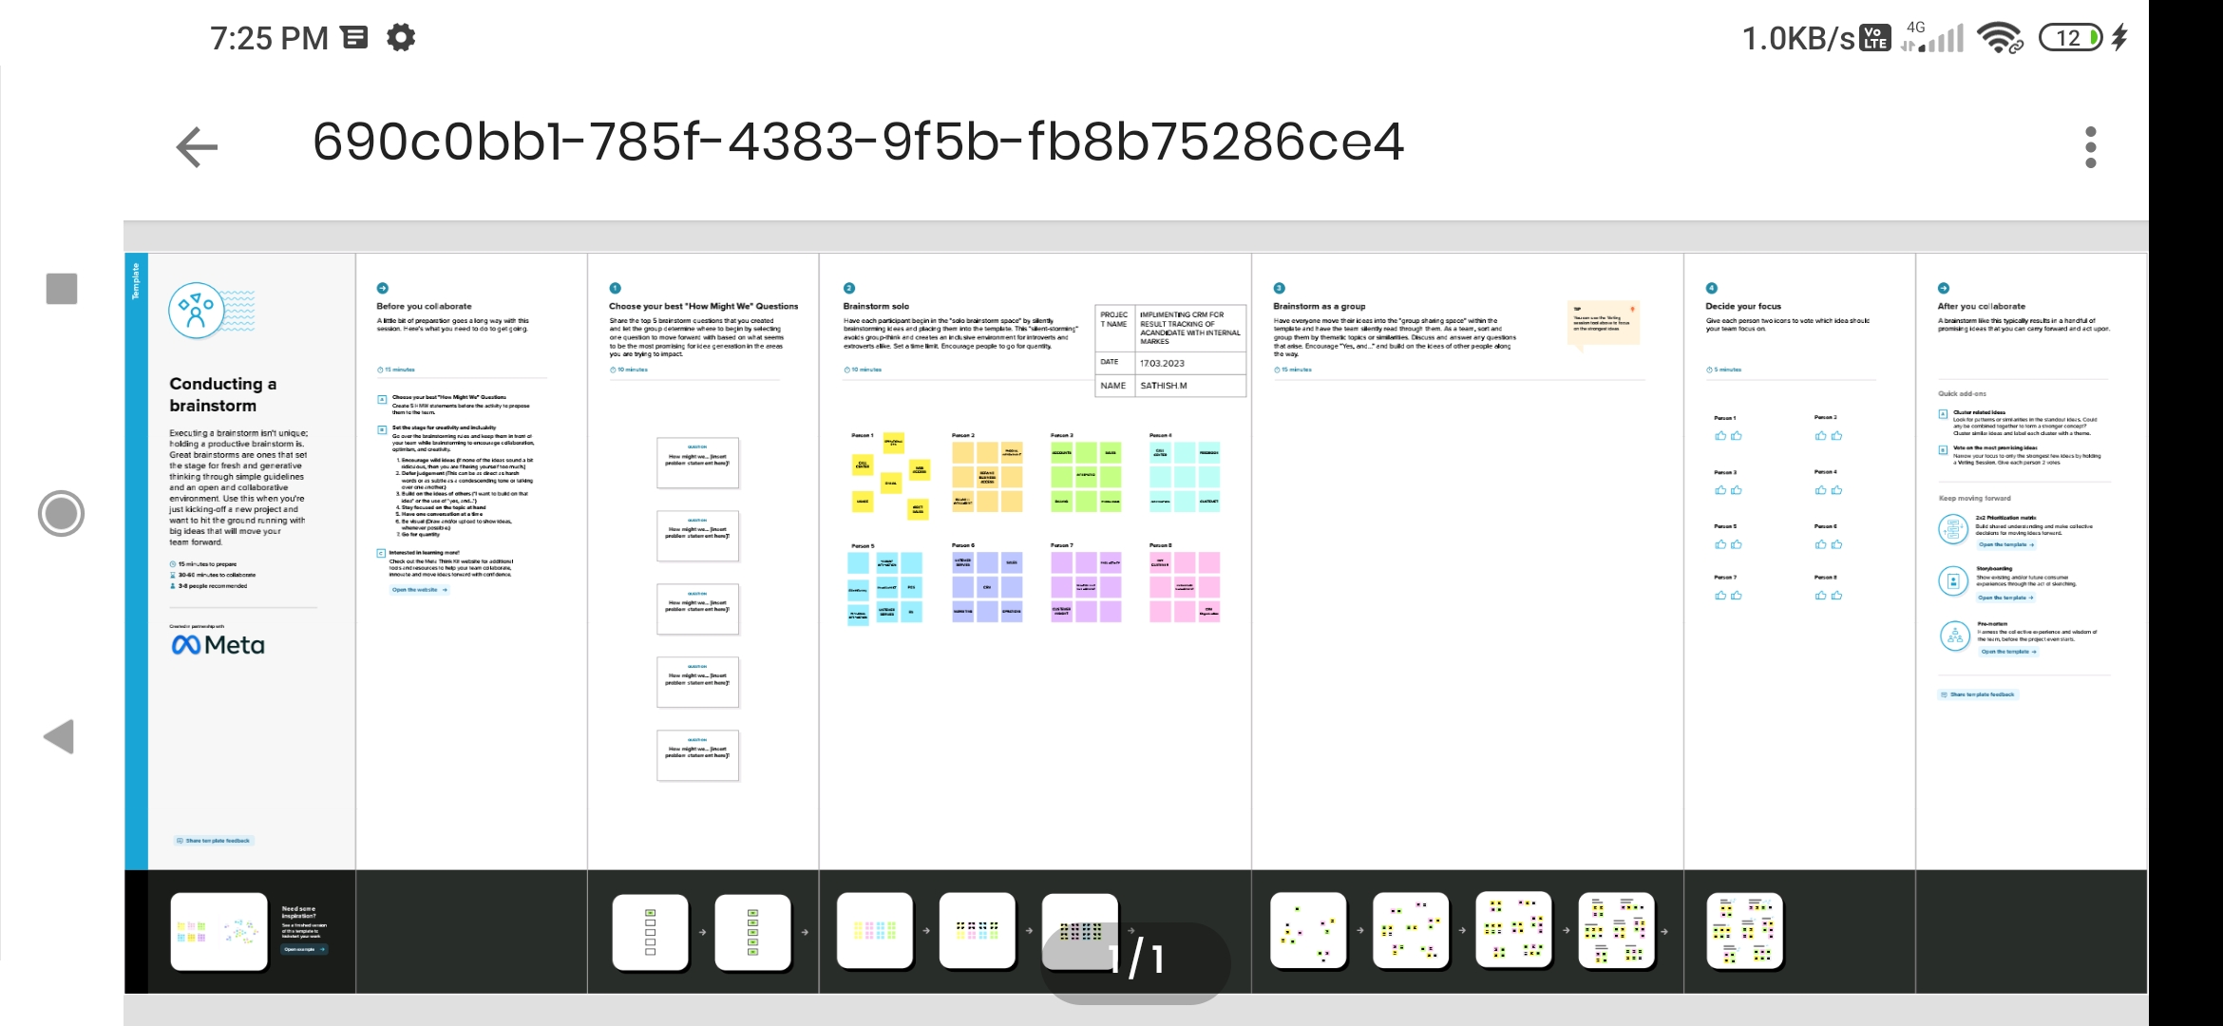

**3. RESULT**

**3.1 Data Model :**

|  |  |  |
| --- | --- | --- |
| Object name | Field label | Data type |
| Recruiter | Job titile | Auto number |
| Recruiter | description | Text area |

**3.2 Activity & Screenshort :**

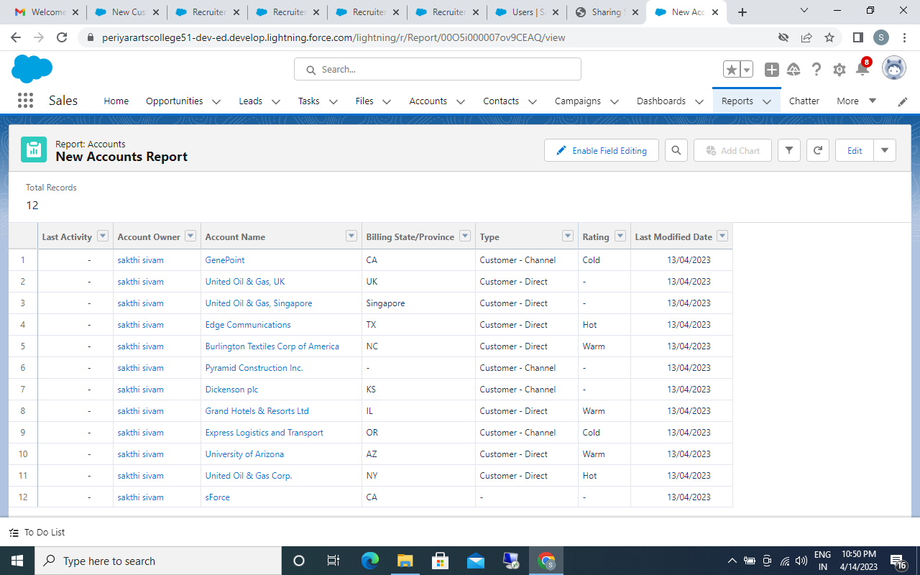

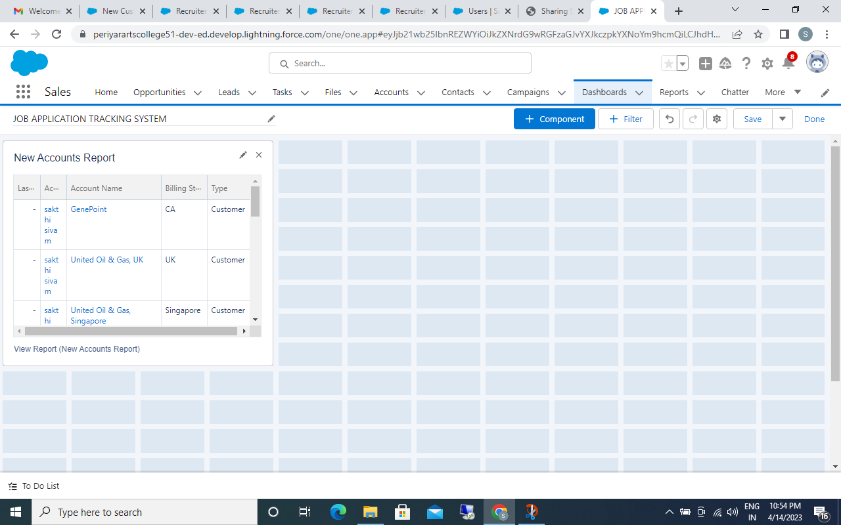

**4. TRAILHEAD PROFILE PUBLIC URL**

Team Leader - <https://trailblazer.me/id/vvinayagamoorthy>

|  |
| --- |
| Team Member 1 - <https://trailblazer.me/id/vijayan070403> |
| Team Member 2 - <https://trailblazer.me/id/ppooja98>In new window |

|  |
| --- |
|  |

Team Member 3 - <https://trailblazer.me/id/vvinithkumar1>

**5. ADVANTAGES & DISADVANTAGES**

**Advantages :**

* Streamlines recruiting. ...
* Posts jobs on multiple job boards. ...
* Saves time by automating mundane tasks. ...
* Builds your brand. ...
* Manages talent database. ...
* Promotes easy collaboration among the recruiting teams.

**Disadvantages :**

* A Disadvantage of ATS is missing qualified applicants due to wrong keyword selection.
* Automatic elimination of resumes that software cannot recognize and interpret is another drawback of ATS.
* An Applicant Tracking System Disadvantage is that they are open to manipulation.

**6. APPLICATIONS**

* Career page
* Job Distribution portal
* Application sarting tool
* Resume storge box
* Messenger and interview scheduler

**7. CONCLUSION**

Applicant Tracking System for recruiters is a very effective hiring solution that most of the successful recruiters utilize. Because without it, there is a good chance that your process of moving applicants through different stages can become very difficult.

**8. FUTURE SCOPE**

The project has a very vast scope in future . The project can be implemented on internet in future.